SESSION 6
1.build array from permutations
class Solution {
public int[] buildArray(int[] nums) {
int[] ans = new int[nums.length];
for (int i = 0; i < nums.length; i++) {
ans[i] = nums[nums[i]];
}
return ans;
}
}
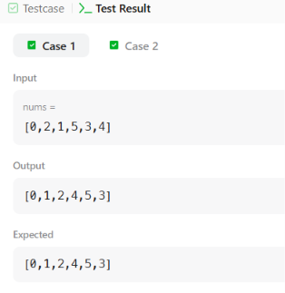 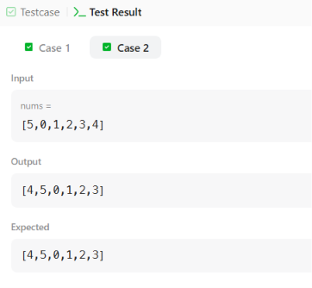

2.suffle the array
class Solution {
public int[] shuffle(int[] nums, int n) {
int[] ans = new int[2 * n];
for (int i = 0; i < n; i++) {
ans[2 * i] = nums[i]; // Places x1, x2, ..., xn
ans[2 * i + 1] = nums[i + n]; // Places y1, y2, ..., yn
}
return ans;
}
}
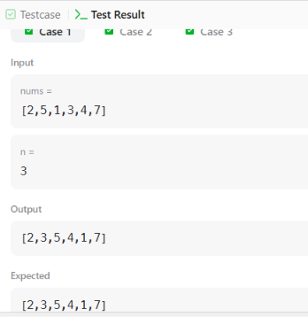 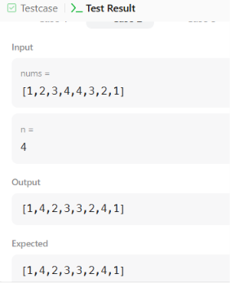

SESSION 8
3.FIND THE HIGHEST ALTITUDE
class Solution {
public int largestAltitude(int[] gain) {
int maxAltitude = 0;
int currentAltitude = 0;

for (int i = 0; i < gain.length; i++) {
currentAltitude += gain[i];
if (currentAltitude > maxAltitude) {
maxAltitude = currentAltitude;
}
}

return maxAltitude;
}
}
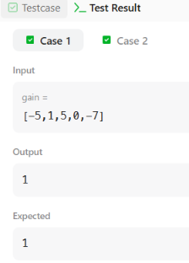 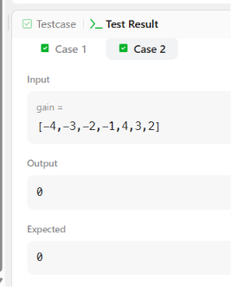

SESSION 10
4.JAVA DEQUEUE
import java.util.*;

public class Solution {

public static void main(String[] args) {

Scanner in = new Scanner(System.in);

int n = in.nextInt();
int m = in.nextInt();

Deque<Integer> deque = new ArrayDeque<Integer>();
HashMap<Integer, Integer> map = new HashMap<Integer, Integer>();

int maxUnique = 0;

for (int i = 0; i < n; i++) {

int num = in.nextInt();

deque.addLast(num);

if (map.containsKey(num)) {
map.put(num, map.get(num) + 1);
} else {
map.put(num, 1);
}

if (deque.size() == m) {

maxUnique = Math.max(maxUnique, map.size());

int removed = deque.removeFirst();

if (map.get(removed) == 1) {
map.remove(removed);
} else {
map.put(removed, map.get(removed) - 1);
}
}
}

System.out.println(maxUnique);

in.close();
} }
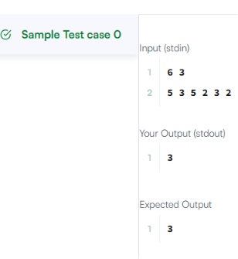
5.JAVA HASH SET
import java.io.*;
import java.util.*;
import java.text.*;
import java.math.*;
import java.util.regex.*;

public class Solution {

public static void main(String[] args) {
Scanner s = new Scanner(System.in);
int t = s.nextInt();
String [] pair_left = new String[t];
String [] pair_right = new String[t];

for (int i = 0; i < t; i++) {
pair_left[i] = s.next();
pair_right[i] = s.next();
}

Set<String> set = new HashSet<>();

for (int i = 0; i < t; i++) {
set.add(pair_left[i] + " " + pair_right[i]);
System.out.println(set.size());
}

}
}
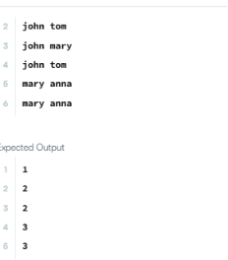
SESSION 4
6.RICHEST COUSTMER WEALTH
class Solution {
public int maximumWealth(int[][] accounts) {
int maxWealth = 0;

// Iterate through each customer (row)
for (int i = 0; i < accounts.length; i++) {
int currentCustomerWealth = 0;

// Sum all accounts (columns) for the current customer
for (int j = 0; j < accounts[i].length; j++) {
currentCustomerWealth += accounts[i][j];
}

// Update the maximum wealth found so far
if (currentCustomerWealth > maxWealth) {
maxWealth = currentCustomerWealth;
}
}

return maxWealth;
}
}
